
Selection Table 2: Large office 220V shredding solution (silent, beautiful, safe) v2024.9.24
User groups: government agencies, offices Destruction: vouchers, drawings, archival documents, orders
 | Plan 1:YD-23026C | Plan 2:YD-3120C | Plan 3:YD-310CC | Plan 4:YD-418CC | Plan 5:YD-330CC | Plan 6:YD-338CC26 | Plan 7:YD-PSJ300(2P1.5K)
Pricing USD | $405 | $1,407 | $2,653 | $3,969 | $5,495 | $5,642 | $5,599
Entry Image | 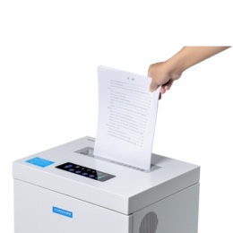 | 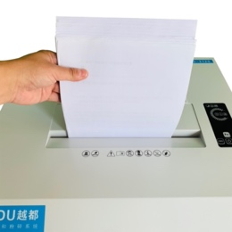 | 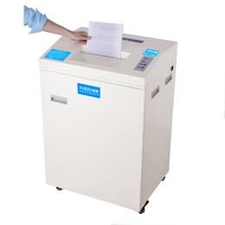 | 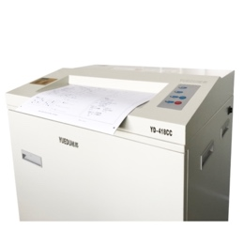 | 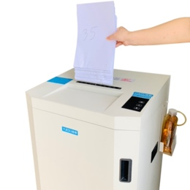 | 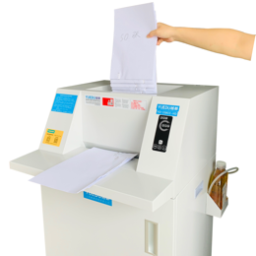 | 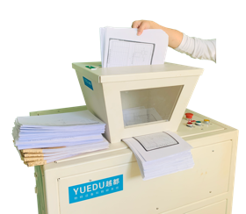
Full  Image | 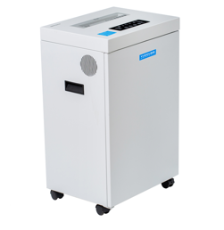 | 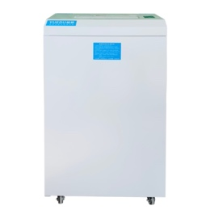 | 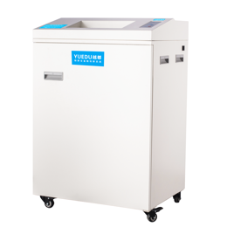 | 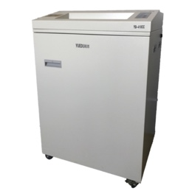 | 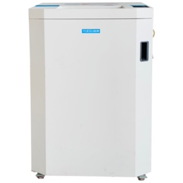 | 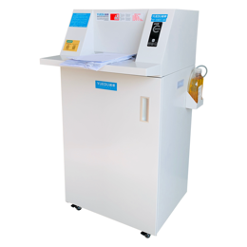 | 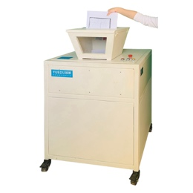
Features | 6,000 sheets per Hour | 25-40 KG per hour | 40-60 KG per hour | entrance 40CM, convenient for drawings | Auto-refueling, silent, double inlet | Auto-refueling, silent, double inlet | High horsepower, double inlet  Fragile hard drives
Sheets | 25 | 25 | 35 | 25-32 | 42-52 | 38-60 | 40-130
Entry width | 24CM | 31CM | 31CM | 41CM | 33CM | 33.8CM | Funnel Entry 50*38CM
Applicable Scenarios | Broken bank cards  office | Large office | Enterprise Factory  Chain  government | Institute | Government departments, multinational corporations | Industry leader  Multinational  Government | Industry leader  Multinational  Pharmaceutical  Records management
 | https://youtu.be/1wFfDEN51Yk  https://youtu.be/s0kGUMf7BVs | https://youtu.be/U9MJ1mHHmjU | https://youtu.be/pnUcwZMjxdI  https://youtu.be/SwA5s6qFbhY | https://youtu.be/wGP2alVsmWk  https://youtu.be/BWDK4yZyG_U | https://youtu.be/yrWEiYl2YOA | https://youtu.be/1EfhdA9yHHA  https://youtu.be/5V-NGy5HUaM | https://youtu.be/VhKA0DnCQ8Y  https://youtu.be/IUsy2eLjN4c
Typical users | Bank  Law Firm | Tesa SE  Innovia Security  RBIS | FAW Toyota  Volkswagen  Foxconn | Alfa Laval  Nippon Paint  Canon | Heidelberg  J&J  GSK | 3M Labels  Panasonic  Eli Lilly | Avery Dennison  Merck  Ford Motor

